ANIMALS AND COAT OF ARMS
Животные в геральдике
8 классы
Преподаватель: Воскресенская Г.В.
ГБОУ РК «КУВКИЛИ» г. Керчь
Цели: Развитие социо - культурной компетенции, художественного вкуса, внимания к деталям, логического мышления, творческого воображения. Развитие мотивации к изучению иностранных языков. Расширение кругозора. Употребление ЛЕ в новом контексте. Развитие умений монологического высказывания.
Оборудование: компьютер, экран, презентация в Power point, сопровождающая рассказы о гербах и изображенных на них животных. Видео фильмы “Тасманийский дьявол”, “ English Coat of Arms History”.
Ссылки на видеоматериалы:
- Тасманийский дьявол, животные Австралии, тасманский дьявол, интересные факты. YouTube. (Продолжительность 2:51)
- “ English Coat of Arms History”. Every Coat of Arms of England and Great Britain. YouTube. (Продолжительность 3:30)
Вступительное слово преподавателя:
Do you know what heraldry is, what and why is usually depicted on the coats of arms in various countries?
Heraldry studies the symbolism of the coats of arms of various countries, states, cities, families. Every detail of the coat of arms has its own significance and is determined by historical events, economy, and cultural life of the country. Each animal in heraldry has a certain symbolic meaning. Even the position of the animal, the turn of its head and paws, its color have a certain meaning. At our holiday today we are going to speak about animals in heraldry. The coats of arms of Russia, Crimea, Kerch, the coats of arms of English-speaking countries, the coats of arms depicting exotic and mythological animals of lots of other countries of the world will be shown and described by the students of 8 “B” form.
So, we begin.
Student 1. General information.
Every country has its symbols: has its Coat of Arms, Flag and Anthem. A lot of countries have animals in Coat of Arms design. We are going to dwell on such Coat of Arms. Some countries have real animal design like Malawi with a lion and a leopard. Some countries have mythical animal design like the city of Kerch, Russia with the Griffin. Some counties have both real and mythical animal design like Scotland with a lion in the centre and two unicorns as shield holders.
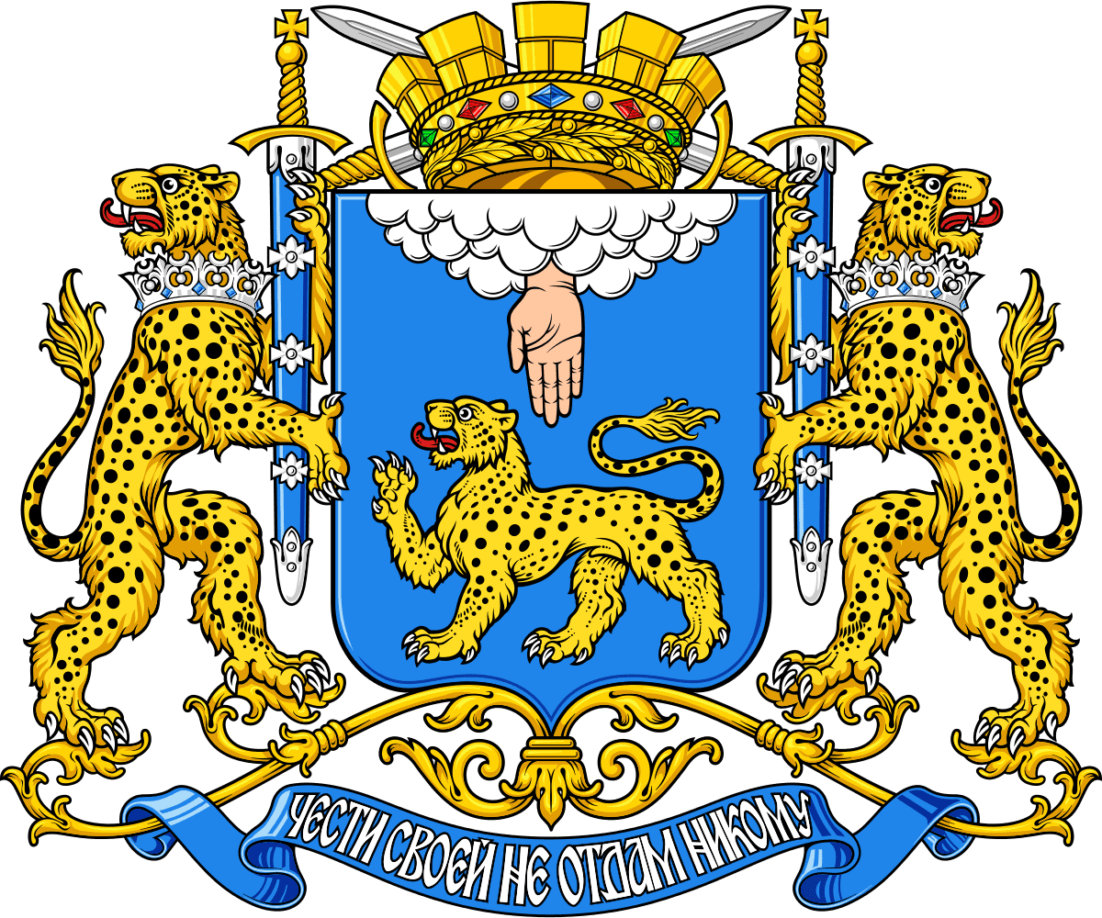  Malawi. Leopard. | 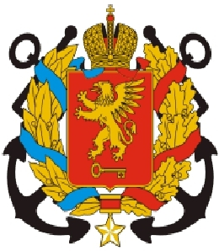  Kerch. The Griffin | 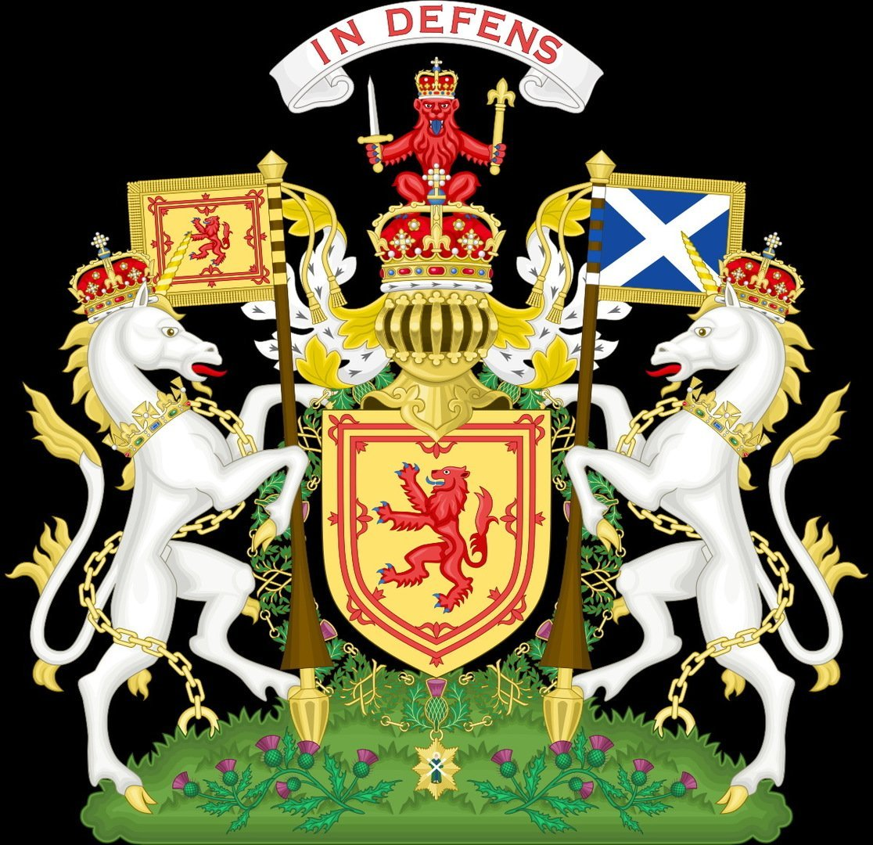  Scotland. Lion and Unicorns

No doubt, every animal on a Coat of Arms means something definite. Have a look at the following animals and think about possible characteristics these animals can bear and chech with the explanation.
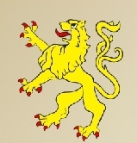 | Lion is the symbol of courage - отвага, strength - сила, - anger гнев, generosity – великодушие. | 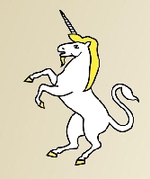 | Unicorn is the symbol of invincibility – непобедимость, purity - чистота | 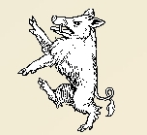 | Boar means fearlessness бесстрашие.
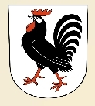 | Rooster means belligerence – воинствен -  ность | 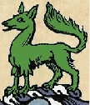 | Wolf means anger and greed - злость и жадность | 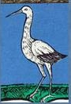 | Crane means vigilance and caution -бдительность и осторожность
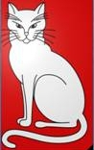 | Cat means independence – независи-мость. | 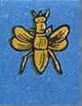 | Bee means hard work -трудолюбие | 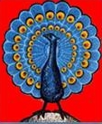 | Рeacock means bragging - хвастовство

Student 2. Let’s have a look at definite countries’ coats of Arms. Let’s begin with the Coat of Arms of our country, Russia.
Eagle is one of the most popular symbols in heraldic. It is the symbol of power and domination, generosity and perspicacity (символ власти и господства, великодушия и прозорливости). The double - headed eagle of Russia (двуглавый орел) means unity and protection of western and eastern parts of Russia and its history. In the middle - a white horse with a rider St. George the Victorious is trampling a black snake (белый конь топчет черного змея) which is the ancient symbol of the victory of good over evil.
The Crimean Coat of Arms is Griffin, a mythical creature which has a body of a lion, a head and wings of an eagle. Griffin is the guardian of the earth and air, the symbol of courage (хранитель земли и воздуха, символ мужества). We can also see a pearl – it’s Crimea itself, rising sun means prosperity.
The Coat of Arms of Kerch also has the Griffin as the guardian of the earth and air, the symbol of courage. The golden key means the key to the strait between the Black sea and the Sea of Azov. There are also two anchors that symbolize two seas and two ports: the trade port and the fish port. The golden star shows that Kerch is a hero-city.
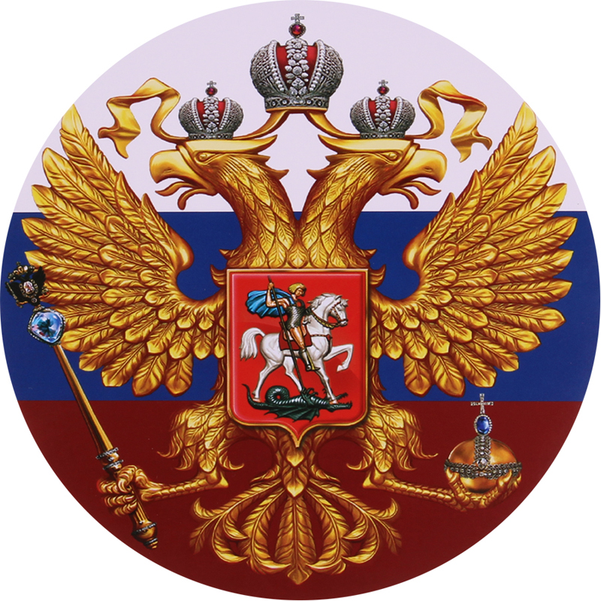  Russia | 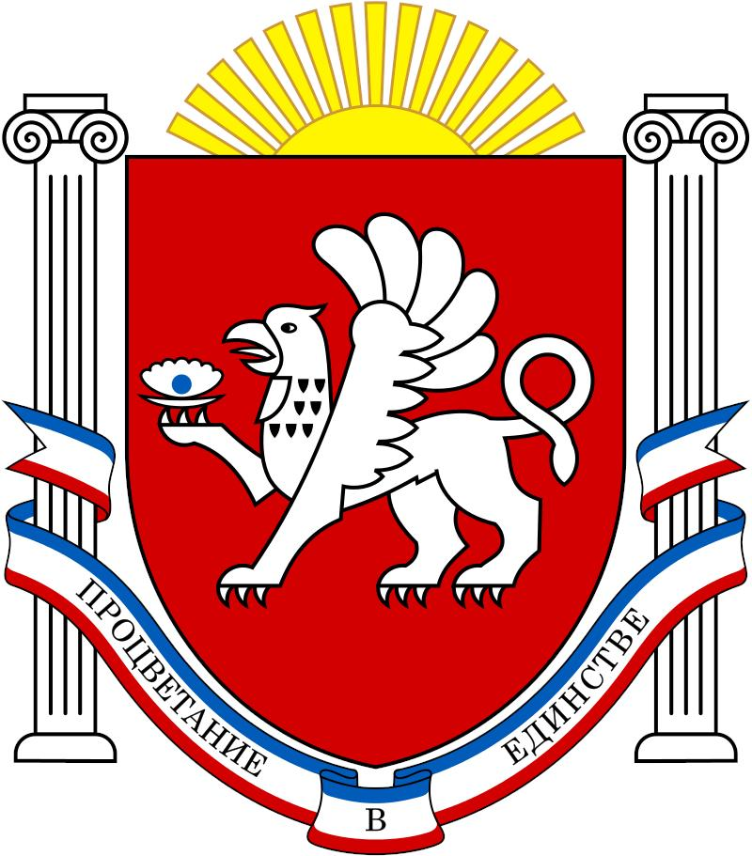  Crimea | Kerch

Student 3. The Coats of Arms of the English-speaking Countries.
The United Kingdom of Great Britain and Northern Ireland consists of 4 countries: England, Scotland, Wales and Northern Ireland.
Have a look at the Coat of Arms of The United Kingdom. The round shield in the centre consists of 4 parts: two parts in the red background with 3 walking lions on each refer to England. One lion standing on his back paws refers to Scotland. The fourth part doesn’t have an animal as its symbol, it has a musical instrument – a harp and it refers to Northern Ireland. We can also see two animals that hold the shield. They are a lion and a unicorn. The lion symbolizes power and the unicorn symbolizes purity of ideas and actions of the country.
The Coat of Arms of England was made in 1195 under the king - Richard the Lion-hearted (Ричард Львиное Сердце). Actually, these creatures in heraldic are called leopards, but the English prefer to call them lions walking on the alert (львы, идущие настороже). The lion is a symbol of strength, courage and generosity, and the leopard is a symbol of bravery and courage.
The Coat of Arms of Scotland has lions on the crown and in the middle – its Lion rampant. You know that lions symbolize power. There are also two unicorns that are the symbols of invincibility (непобедимость) and purity (чистота).
The Coat of Arms of Wales has lions too. We can see 4 golden and red lions that symbolize power and wealth. The wreath of symbolic flowers – thistle, shamrock, leek and the roses of the Tudors - surround the coat of arms. The words written on the green ribbon say: I am loyal to my country.
Another country of the UK is Northern Ireland. Here is its Coat of Arms. Again, we can see a lion, symbol of power. And there is an animal which is called the Irish MOOSE. The moose is a natural non-heraldic animal. But it has become widespread in the territorial and municipal heraldry of various countries. It symbolizes a unique nature, strength, determination, courage and power.
So, we can make a conclusion that the central heraldic animal on the Coats of Arms of the counties that make up the United Kingdom is the lion that symbolizes power. Lion is the most widespread figure in heraldic.
There is also a Mythical animal – unicorn that symbolizes invincibility and purity. A moose is not a traditional heraldic animal but it is a “territorial” decision to have a moose on the coat of arms.
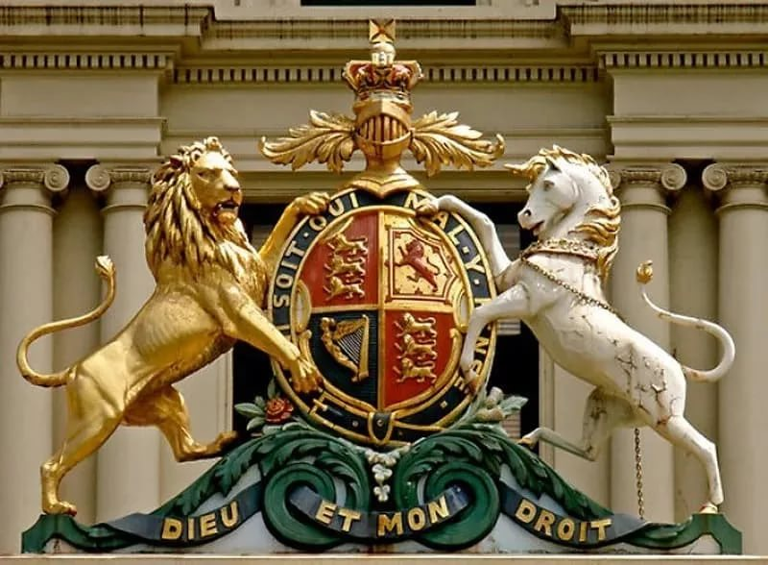  The United Kingdom | 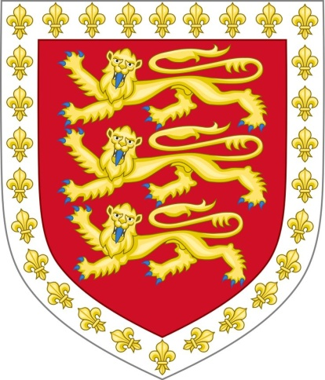  England | 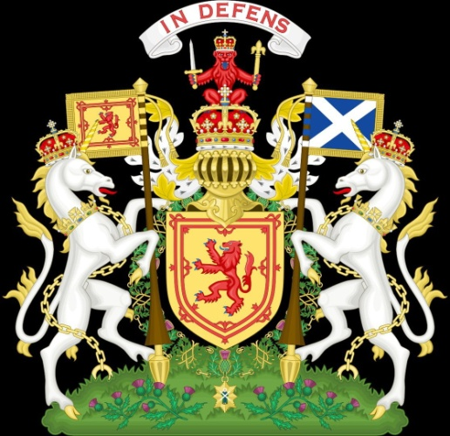  Scotland
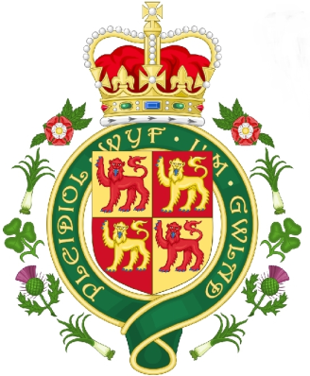  Wales | 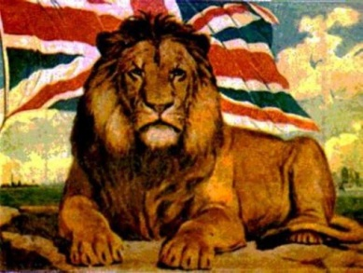 | 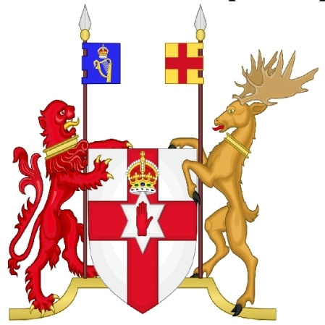  Northern Ireland

Демонстрация фильма об истории создания герба Англии.
Other English-speaking countries
North American Continent
Student 4.
Canada 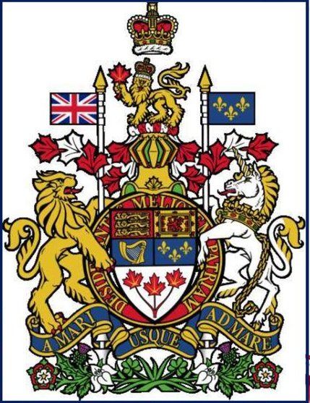 | Let’s have a look at the Coat of Arms of Canada. As we can see, it has a lot of details. There are 5 parts in the shield. 4 parts symbolize the countries where the ancestors, or forefathers, of Canadians came from. So 3 golden lions symbolize England, Red lion standing on the back paws symbolizes Scotland, the golden harp symbolizes Ireland and 3 golden lilies are from France. The fifth part – 3 red maple leaves are the symbol of development of new nation that consists of so many nationalities. Flags of Great Britain and France, heraldic flowers and shield holders show that Britain and France played the great role in the history of Canada. There also two official languages in Canada: English and French. As for shield holders, we can easily recognize the lion of England and the unicorn of Scotland with the same symbolic ideas: power, generosity, invincibility and purity.

Student 5. The USA and its symbols.
The national symbol of the USA is bald eagle, because this species of eagles lives only on the continent of North America. Bald eagle (белоголовый орлан, лысый орел) is the symbol of sovereignty and power. The bald eagle has the colours of American flag on its chest: red, white, blue. The Coat of Arms was adopted in 1772, its final modification was adopted in 1884. The ribbon in the eagle's beak with the Latin motto "One out of many" shows that the USA is the unity of many states. The motto is taken from the treatise of the ancient Roman politician and philosopher Cicero "On duties".
The Coat of Arms is also used as state seal.
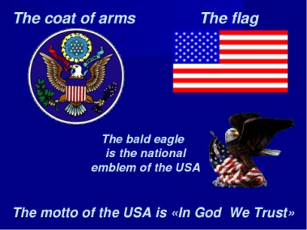 | 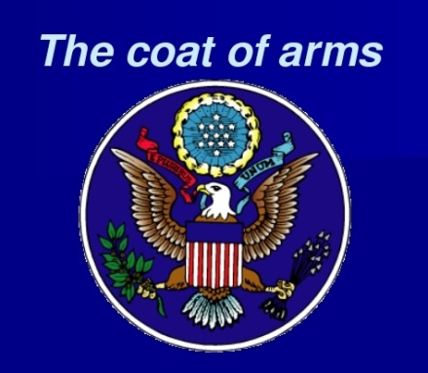 | 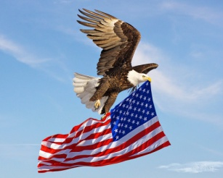

Student 5. Australia.
Australia  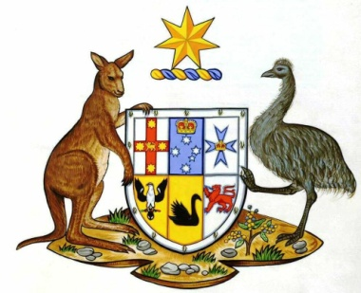 | Now, we’ve come to another part of the world, to both a country and a continent Australia. The modern picture of Australian coat of arms was adopted in 1912. Looking at this Coat of Arms we understand that Australia has its special flora and fauna. Almost all animals and birds live only in Australia. The red kangaroo and the emu ostrich, that are shield holders, live only there. The Coat of Arms itself is divided into 6 parts, it means that Australia consists of 6 states and each state has its symbol. 3 states in the upper part have crosses and stars as their symbols, 3 states in the lower part have animals as their symbols:  The South Australian symbol is piping shrike (птица-сорокопут), Western Australia’s symbol is a black swan (лебедь), Tasmania’s symbol is a red lion.  In a word, Australian symbols show uniqueness and diversity of the animal world of Australia. The country is very proud of its unique animal world and reflects it in its Coats of Arms.

Student 6.
New Zealand  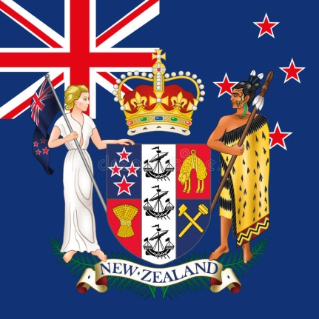 | New Zealand is a big island not far from Australia. Look at its Coat of Arms. We cannot see any animal on the Coat of Arms of New Zealand. This Coat of Arms reflects industries of the country. Golden fleece is the product of sheep breeding, so it symbolizes cattle breeding. In the lower left part we can see a sheaf of wheat (сноп пшеницы) symbolizing agriculture; in the lower right part there are two hammers symbolizing mining and industry. We can also see three ships on a middle vertical stripe. They symbolize the importance of maritime trade for New Zealand on the one hand and the immigrant origin of New Zealanders – on the other.  Shield holders are not animals as on all other Coats of Arms. The New Zealand Coat of Arms shield holders are a white blode European woman holding the New Zealand flag and a Māori chieftain holding a taiaha ([ˈtaiaha]), a traditional weapon of the Māori of New Zealand.

Student 7.
India  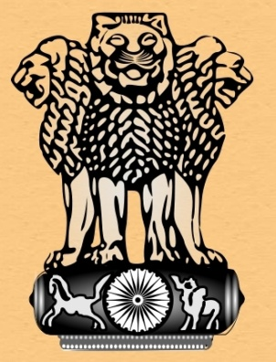 | India is one of the countries which official language is English. It’s a very interesting country with rich history and philosophy. Indian philosophy is seen in its Coat of Arms. Look, we can see The Lion 's Capital – the combination of four lions. Lion in India is the symbol of the Buddha. Four lions on the coat of arms symbolize the nation that is "courageous in bravery, strong in body, prudent in advice, the nation which frightens its enemy”(«отважна в храбрости, сильна в теле, благоразумна в совете и устрашает противников»). The lions are standing on a wheel which is called abaca, it is the Buddhist "wheel of law", it looks like a drum. The abaca is decorated with four animal symbols of four directions, four sides of the world: Lion – north, Elephant – east, Bull – south and Horse – west. Abaca is standing on a flower. It is a lotus in full bloom, symbolizing the source of life (источник жизни).  As we can see, Indian Coat of Arms and its meaning differs greatly from Coats of Arms of other English-speaking countries.

Student 8. I’m going to tell you about exotic animals on Coats of Arms of some countries.
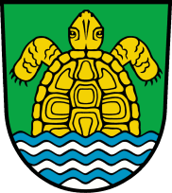 | Let’s begin with turtles. Heraldic turtle is the symbol of fishing and fishing industry, insensitivity (невосприимчивость), impassibility (бесчувственность), development, and also wisdom. The turtle is a natural non-heraldic figure, common in some states, some areas, and in family heraldry. Here are some Coats of Arms with turtles.
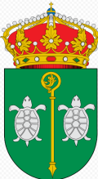  The Coat of Arms of the Galapagos Islands. There are a lot of turtle species there. | 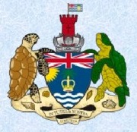  The Coat of Arms of the British territory in the Indian Ocean. There are a lot of turtle species there too. | 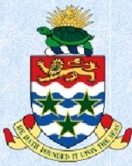  The Coat of Arms of the Cayman Islands. A lot of species of turtles live there.
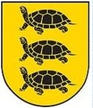  The Coat of Arms of the city of Seiriyai in Lithuania (город Сейрияй в Литве) | 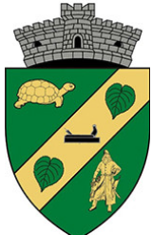  The Coat of Arms of a small village of Dudeshtiai Noi in Pomania (село Дудештия Нои в Румынии) | 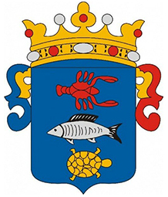  The Coat of Arms of a small but very beautiful village of Bankonsege in Hungary (Баконсеге в Венгрии).
Vancuver. Canada  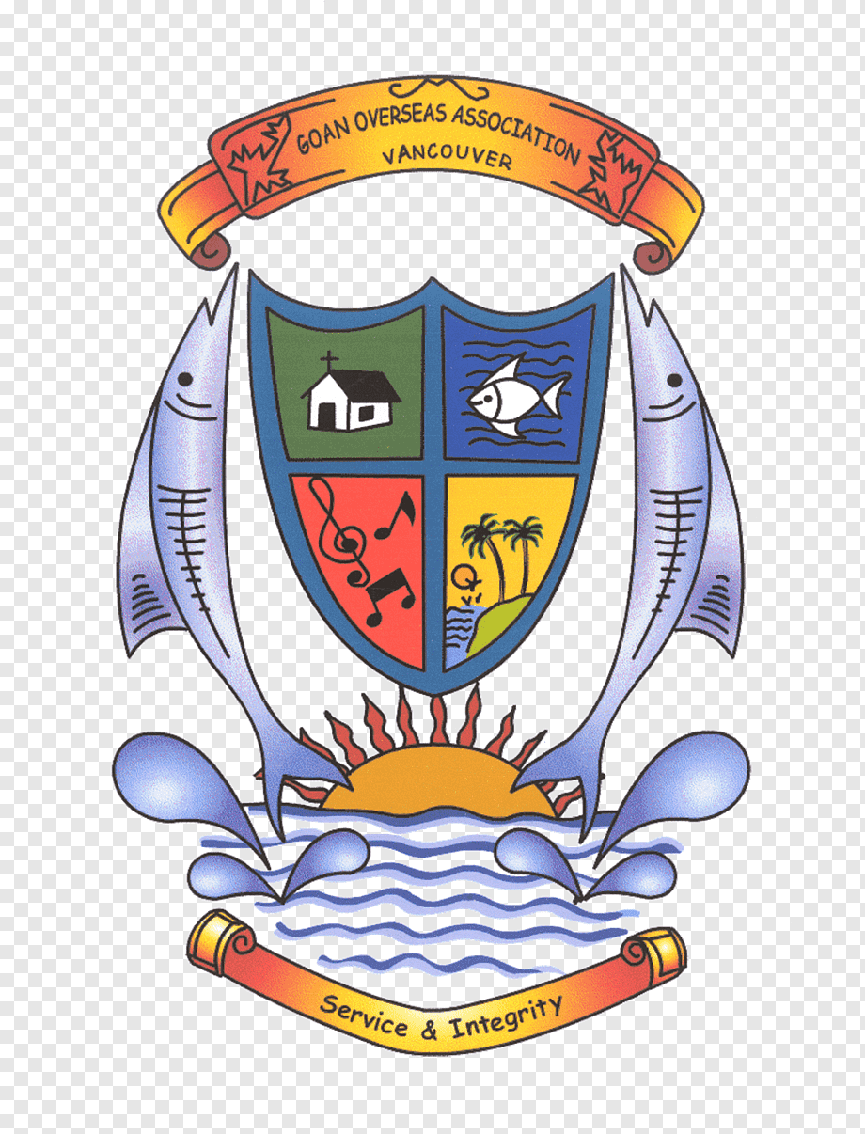 | On the Coat of Arms of Bankonsege we can also see other animals: Crayfish and Fish.  Crayfish symbolizes purity of local lakes and rivers, clean water. Sometimes Crayfish embodies slowness, caution and order (олицетворяет медлительность, осторожность и порядок).  Fish on the Coats of Arms usually means that fish industry is well-developed in this area.  There is another Coat of Arms with Fish design. It’s one of fish undustry firms of Canadian city of Vancuver.

Student 9. Other Exotic animals.
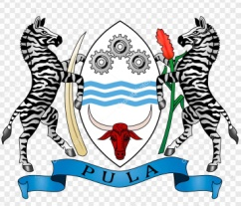 | The Coat of Arms of Botswana – an African country. There are two zebras as shield holders. Zebra is considered the national animal of the country. The bull's head represents the high importance of cattle breeding for the economy of Botswana.
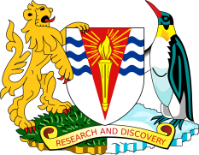 | The Falkland Islands are in the south-western part of the Atlantic ocean. It is the territory of Britain. So, we can see traditional British Lion. But The Falklands are close to Antarctic, so we can also see a penguin as a shield holder.
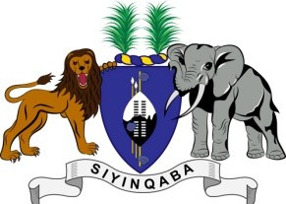 | Many African countries use the Elephant on the Coat of Arms.  Eswatini (Свазиленд) Национальный девиз Свазиленда «Siyinqaba» в переводе на русский означает «Мы — крепость».
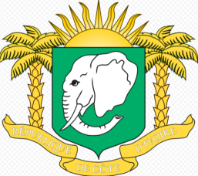 | Ivory Coast (Кот Д‘ивуар).
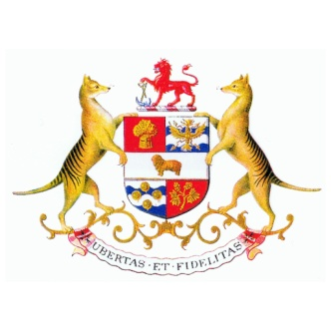 | One of the most exotic animal depicted on the Coat of Arms is The thylacine, or The Tasmanian wolf. Tasmania is the island that belongs to Australia. Tasmanian wolf died out, the last very old wolf died at the zoo in 1936. So, it’s an extinct species. The Tasmanian wolf is very close to Tasmanian devil – another symbol of Tasmania. It is called devil for his huge mouth with sharp teeth, awful night cries and a furious temper (character). It is a predator (хищник).  Tasmanian wolf (тасманийский \сумчатый волк или тилацин)
Демонстрация фильма о тасманийском дьяволе.
ФОТО
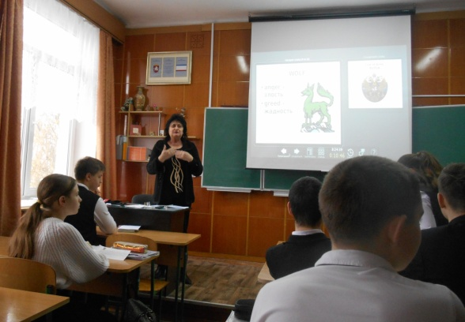  Вступительное слово | 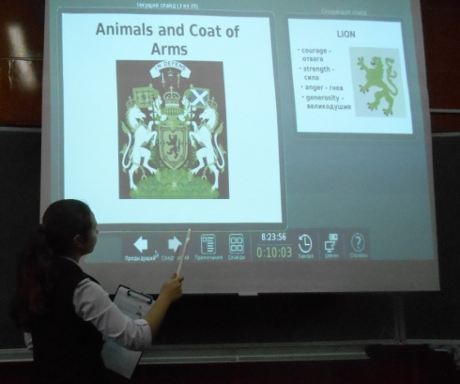  Ксюша. Общая информация
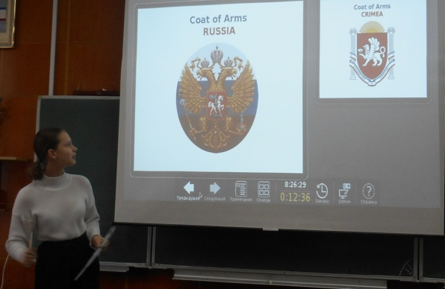  Настя. Россия, Крым, Керчь | 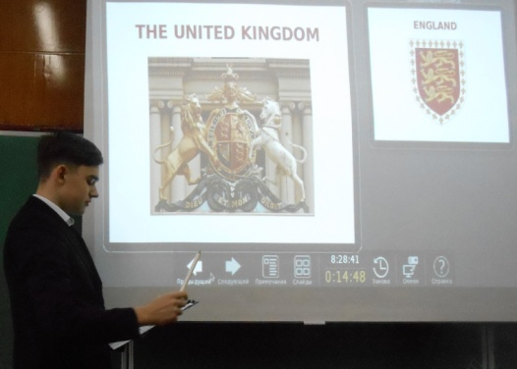  Толя. Великобритания
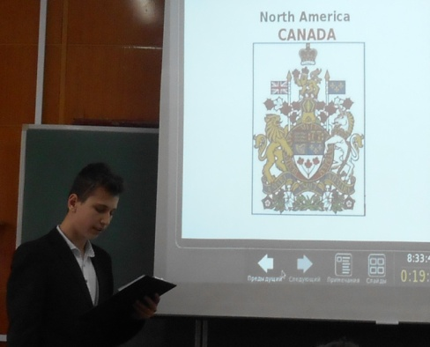  Ярослав. Канада | 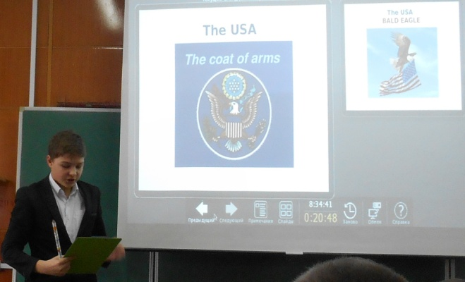  Никита. США
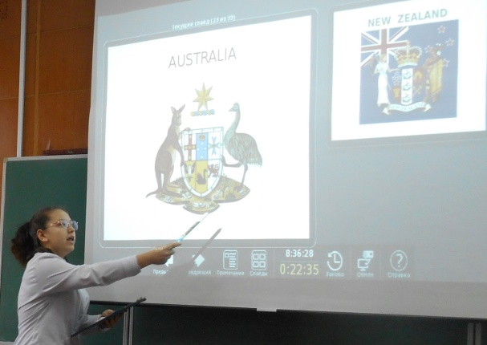  Диана. Австралия | 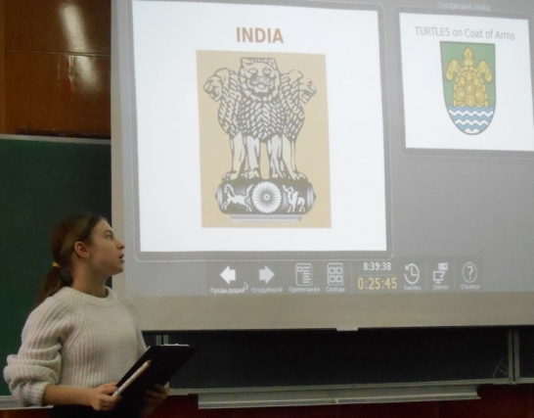  Настя. Индия
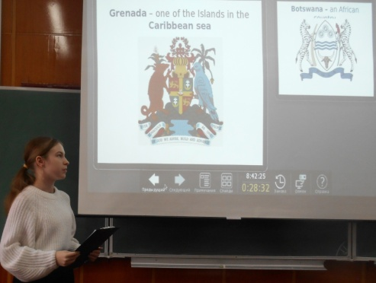  Настя. Экзотические животные на гербе разных стран | 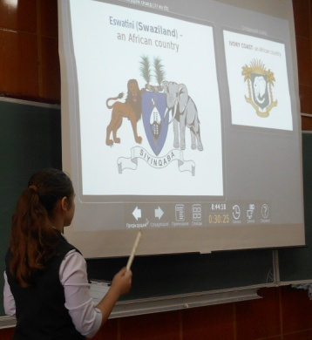  Ксюша. Слоны.
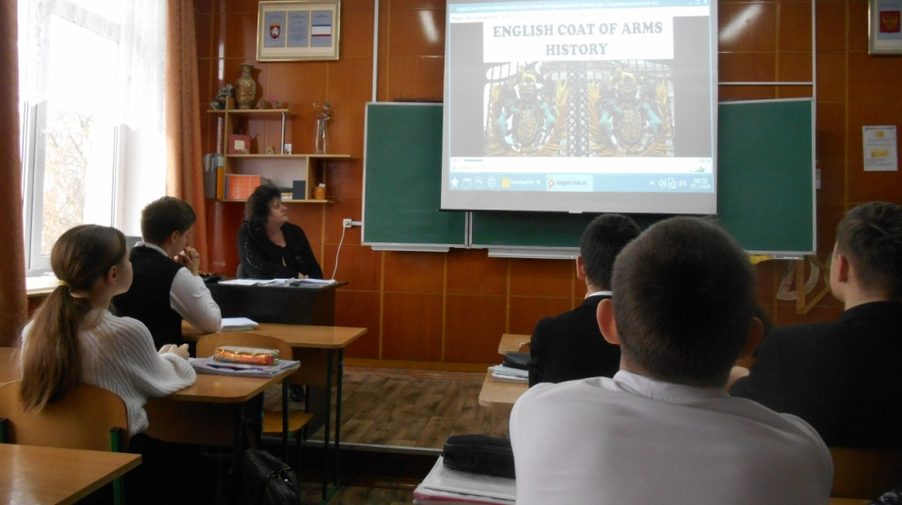
Фильм об истории создания герба Англии
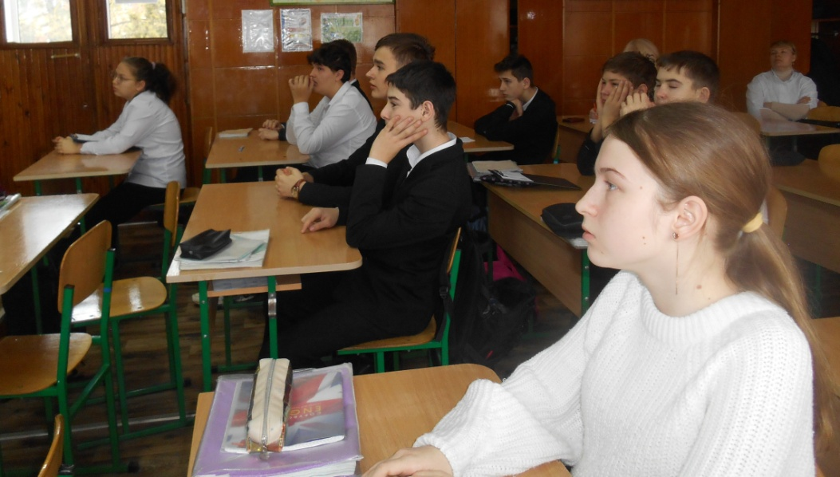
Смотрим фильм о тасманийском дьяволе.
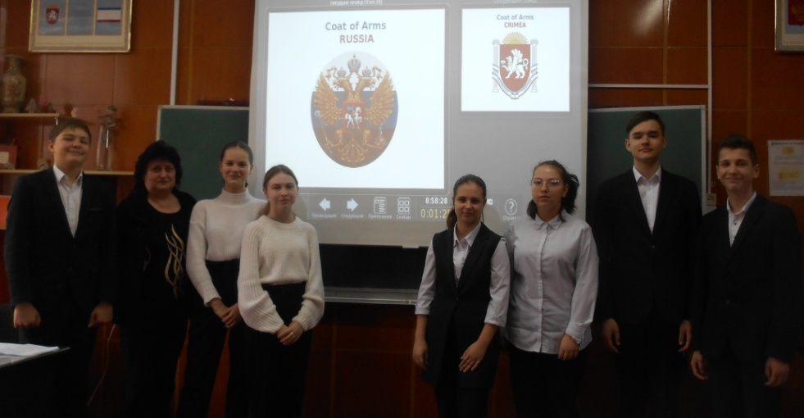
Над мероприятием работали МЫ – 8 «Б»

Итоги. Мнение гостей.

