Внеклассное мероприятие по английскому языку для 6-8 классов «Волшебный мир английских сказок»
Методические рекомендации
Рассчитано на учащихся 6-8 классов
Перед вами разработка викторины, посвященной англоязычным писателям-юбилярам 2022г. Преимущество данной викторины заключается в том, что все задания представлены в игровой форме, что способствует повышению интереса к английской литературе у участников. Главный упор сделан на популярные произведения англоязычных авторов, актуальные для этого возраста, но для расширения кругозора учащихся упоминаются и менее известные широкому кругу писатели. Если выполнять викторину внимательно, в некоторых заданиях можно найти подсказки. В данной разработке сочетаются задания на логику, внимание, сообразительность, знание произведений наиболее популярных для этого возраста авторов в рамках школьной программы и за ее пределами. Используются отрывки из оригинальных текстов произведений. При необходимости можно менять порядок и количество заданий
В комплект входит инструкция с ответами и карточки с заданиями для участников (см.Приложение). Для проведения викторины понадобится цветной или черно-белый принтер, бумага для печати карточек с заданиями, ручка. Задание с пазлом разрезать в произвольном порядке. Некоторые задания возможно демонстрировать на доске с помощью проектора
Инструкция для организатора на русском языке, карточки с заданиями - на английском. Максимальное количество баллов- 43. Каждому заданию соответствует определенное количество баллов, исходя из его сложности
Побеждает финалист, набравший наибольшее количество баллов

Таблица заданий с ответами
Инструкция для ведущего | Задание 1 вариант | Ответ | Баллы | Источник
- Свиток с биографией Льюиса Кэррола  В свитке некоторые буквы выделены. Из них сложится псевдоним автора, о котором идет речь |  | LEWIS CARROLL | 2 | Source: Quotes and aphorisms. https://citaty.su/kratkaya-biografiya-lyuisa-kerrolla
- Запутанная история  Текст из произведения Дж. Свифта «Гулливер в стране лилипутов» написан со смещением пробелов. Чтобы выяснить, какие предметы Гулливер отдал императору, необходимо прочесть текст, не разделяя на паузы, и выделить слова по смыслу. |  | Pistols  A scimitar  A watch  Money  a purse  a knife  a razor  a comb  a snuff-box  a handkerchief  a journal-book | 11 | https://studyenglishwords.com/book/Путешествия-Гулливера/92?page=1
- Шифровка  В этом послании, адресованном двум злодеям, некоторые слова зашифрованы древними рунами. Необходимо перевести их на английский язык, указать автора и произведение. В качестве подсказки использовать карточку с английскими рунами | 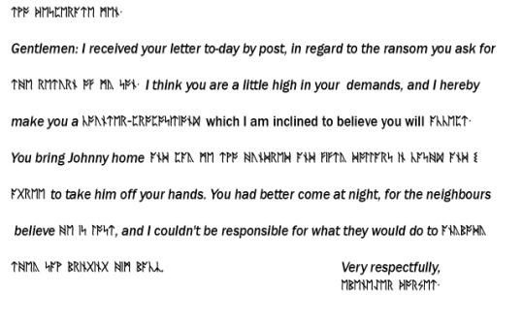 | О`HENRY “THE RANSOM OF RED CHIEF” | 4 | https://studyenglishwords.com/book/Вождь-Краснокожих/88?page=1
- Двусторонний пазл  В этом задании нужно собрать картинку из пазлов, назвать автора и произведение. На обратной стороне собранной картинки прочитать получившееся слово-подсказку, предварительно написанное ведущим | 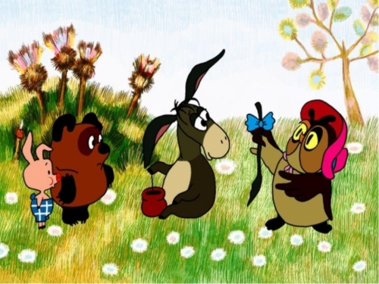 | ALAN MILN | 2
- Зеркальный текст  В Зазеркалье всё отражается наоборот. Вот и этот текст написан зеркально. Прочитать текст и фамилию автора, назвать произведение |  | “ALICE THROUGH THE LOOKING GLASS” | 2 | https://liteka.ru/english/library/2805-through-the-looking-glass#37
- Филворд  Найти в филворде фамилии англоязычных писателей-юбиляров 2022 года |  | 1-Galsworthy  2-Dickens  3-O.Henry  4-Carroll  5-Milne  6-Swift  7-Woolf  8- Tolkien | 7 | ru.wikipedia.org
- Соответствия  Установить соответствия между персонажем и автором, который его создал. Одна картинка лишняя |  | C. Dickens- Oliver Twist  J. Swift- Gulliver  J. R. R. Tolkien-Golum  A. Milne- donkey Eeyore  O. Henry- a kitten and two dogs (“The Ransom of Red Chief”)  L. Carroll- Cheshire Cat  Лишняя- Three Musketeers | 6 | ru.wikipedia.org
- Литературный тест  Ответить на вопросы теста. Из получившихся букв составить фамилию еще одного писателя- юбиляра |  | 1-l  2-e  3-a  4-r  LEAR | 9 | ru.wikipedia.org
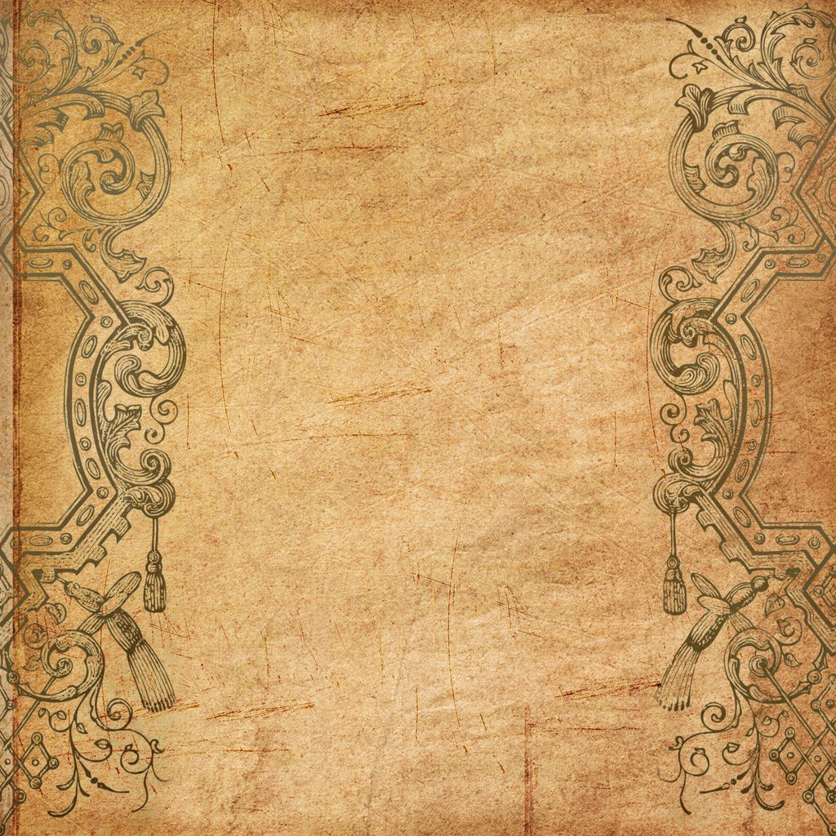
The real name of this author is Charles Latwidge Dodgson (1832-1898), English writer and mathematician. He was born on January 27, 1832 in the village of Darsbury (Cheshire) in a large family of a rural priest. Even as a child, Charles was fond of literature. The future writer wanted to become a priest, like his father, so he entered the University of Oxford at the Faculty of theology, but there he became interested in mathematics.
Then he taught mathematics for a quarter of a century at Christchurch College, Oxford (1855-1881). On July 4, 1862, the young professor Dodgson went for a walk with the family of his friends Liddell. During this walk for Alice Liddell and her two sisters, he told a fairy tale about Alice's adventures. In 1865, Alice in Wonderland was published as a separate book. However, Dodgson, who had already taken the priesthood by that time, could not sign it with his name. He took the pseudonym _____________. The author himself considered "Alice" a fairy tale for adults and only in 1890 released her children's version. After the release of the first edition of the fairy tale, many letters came from readers asking them to continue the fascinating story. He wrote "Alice through the Looking Glass" (published in 1871). The knowledge of the world through the game, proposed by the writer, has become a common technique in children's literature. Books about Alice are not the only works of this author. In 1867, he left England for the only time in his life, going to Russia with his friend. Dodgson described his impressions in the "Russian Diary". He also wrote poems for children and the book "Sylvia and Bruno". The writer himself considered the main business of his life to be a serious mathematical work dedicated to the ancient Greek scientist Euclid. Modern experts believe that Dodgson made the main scientific contribution with his works on mathematical logic. Both children and adults are happy to read his fairy tales. The writer died on January 14 , 1898 in Guildford
Ide livere dupbot hmypisto lsinthes ameman nerasIhad donemy scimitar, an dthenmyp ouch ofpo wderan dbull ets… Ili kewi sedeliver edupmywa tch, which htheempero rwasverycuri oustos ee,andc omman dedtwoof histalle st yeomen ofth eguar ds to earit onapoleupont heirshou lders, as draymen inEn glanddoaba rrelof ale. Ithe ngaveu pmysilve rand coppe rmoney, mypu rse, wit hninelar gepieceso fgold, andso mesmal leron es; mykni feand razor, mycom bandsil ver snuffbox, myhan dkerchi efandjourn al-book
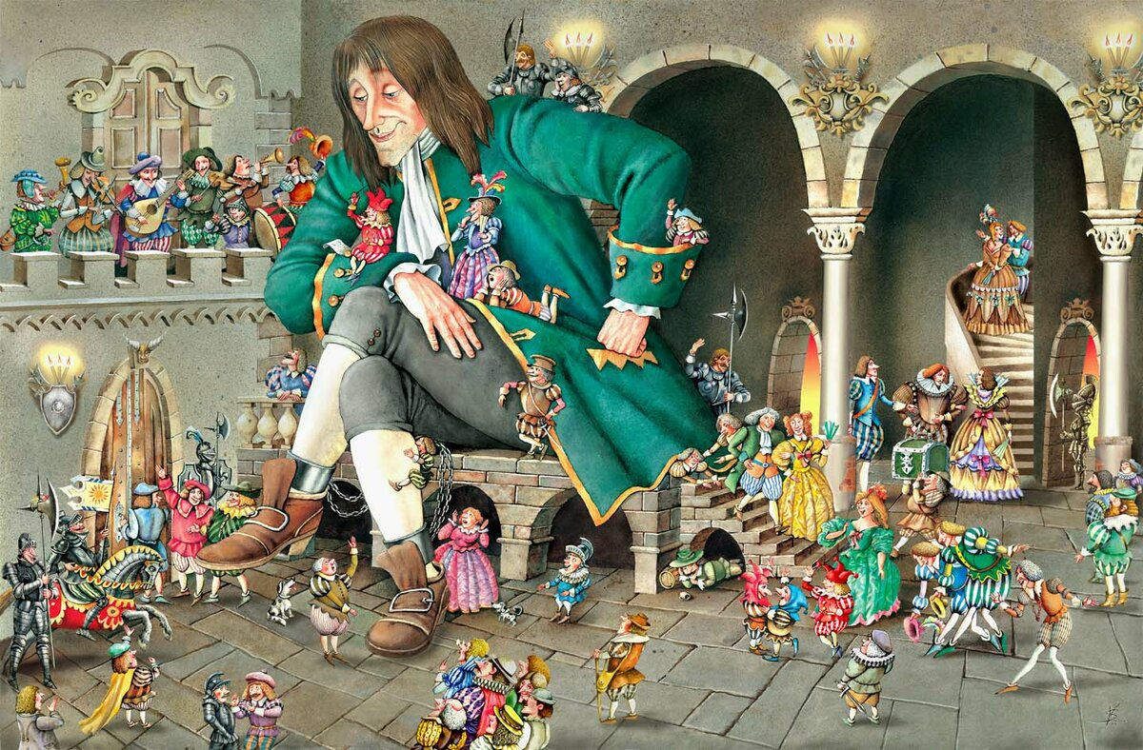

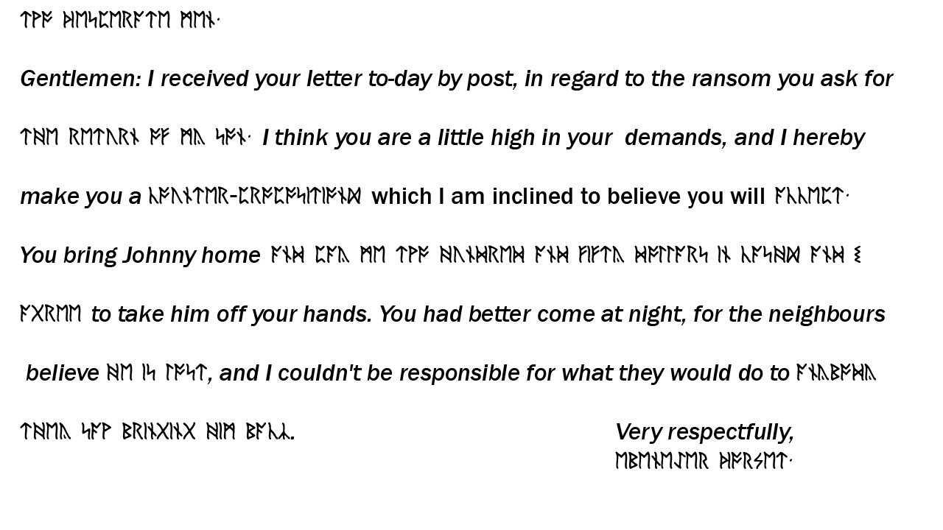
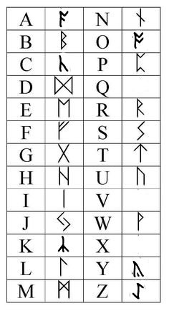

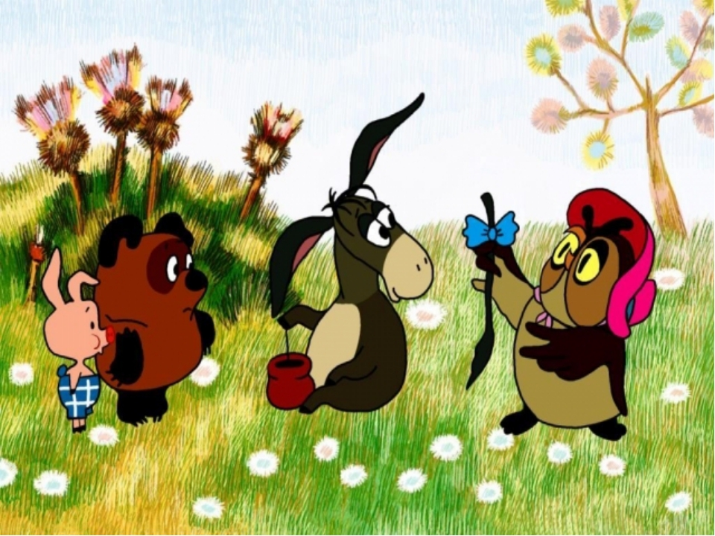

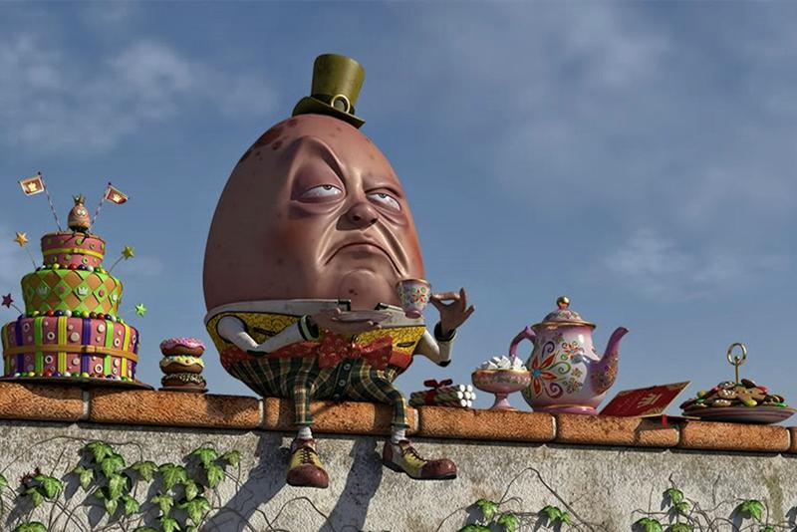
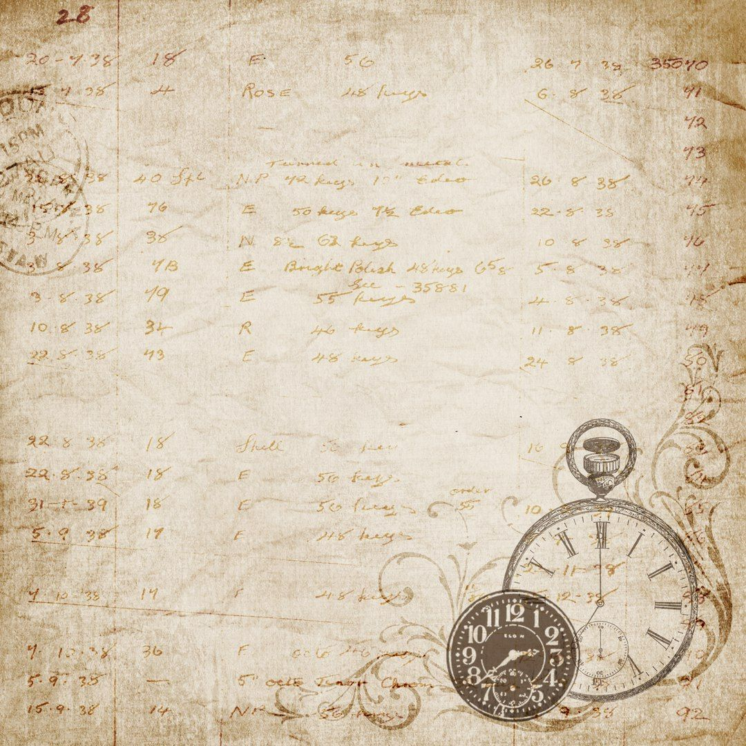  C | M | 1G | J | M | B | E | G | 5M | K
G | 4C | A | R | R | O | L | L | I | A
M | X | L | N | 2D | 7W | O | 3O | L | F
S | T | 6S | W | I | F | T | H | N | Z
A | F | W | B | C | H | B | E | E | F
U | 8T | O | L | K | I | E | N | R | P
I | W | R | Q | E | C | F | R | J | D
O | N | T | D | N | A | E | Y | O | U
Y | I | H | G | S | K | N | V | C | L
V | S | Y | X | H | L | W | H | T | D

- 14 августа 1867, Кингстон-апон-Темс, Суррей — 31 января 1933, Лондон) — английский прозаик и драматург, автор знаменитого цикла «Сага о Форсайтах», лауреат Нобелевской премии по литературе (1932) John____________

- 7 февраля 1812 года, Портсмут, Англия — 9 июня 1870 года, Хайэм (англ.)русск., Англия) — английский писатель, стенограф, репортёр, романист и очеркист. Классик мировой литературы, один из крупнейших прозаиков XIX века, он стал самым популярным англоязычным писателем ещё при жизни. Самые знаменитые романы этого писателя: «Посмертные записки Пиквикского клуба», «Оливер Твист», «Николас Никльби», «Дэвид Копперфилд», «Холодный дом», «Повесть о двух городах», «Наш общий друг», «Большие надежды», «Тайна Эдвина Друда».
Charles John Huffam___________________

- 11 сентября 1862 года, Гринсборо, Северная Каролина — 5 июня 1910 года, Нью-Йорк) — американский писатель, признанный мастер короткого рассказа. Его новеллам свойственны тонкий юмор и неожиданные развязки. Одни из наиболее известных его произведений: «Дары волхвов», «Вождь краснокожих», «Последний лист» и др.
___________________
- 27 января 1832 — 14 января 1898) — английский писатель, математик, логик, философ, диакон и фотограф. Наиболее известные произведения — «Алиса в Стране чудес» и «Алиса в Зазеркалье», а также юмористическая поэма «Охота на Снарка».Профессор математики Оксфордского университета (1855—1881) Lewis _____________
- 18 января 1882, Лондон — 31 января 1956, Хартфилд) — британский писатель, наиболее известный как автор сказочных повестей о «медведе с опилками в голове» — Винни-Пухе. Принимал участие в Первой мировой войне. Много лет был сотрудником английского юмористического журнала «Панч». Сочинять истории о Винни-Пухе Милн начал для своего сына Кристофера Робина Милна (1920—1996). До выхода в свет книг о Винни-Пухе Милн уже был довольно известным драматургом, однако успех Винни-Пуха приобрёл такие широкие масштабы, что другие его произведения сейчас практически неизвестны.
Alan Alexander ______________
- 30 ноября 1667 года, Дублин, Ирландия — 19 октября 1745 года, там же) — англо-ирландский писатель-сатирик, публицист, философ, поэт и общественный деятель, англиканский священник. Наиболее известен как автор сатирико-фантастического романа «Путешествия Гулливера», в котором остроумно высмеял человеческие и общественные пороки. Жил в Дублине (Ирландия), где служил деканом (настоятелем) собора Святого Патрика.
Jonathan ____________
- 25 января 1882, Кенсингтон, Мидлсекс, Англия — 28 марта 1941, Льюис, Суссекс, Англия) — британская писательница и литературный критик. Ведущая фигура модернистской литературы первой половины XX века.
Virginia ____________
- 3 января 1892 года, Блумфонтейн, Оранжевая Республика — 2 сентября 1973 года, Борнмут, Англия) — английский писатель и поэт, переводчик, лингвист, филолог. Один из самых известных писателей, автор более двухсот различных публикаций (37 книг, 63 статьи, 121 перевод) и множества незавершённых работ. Наиболее известен как автор классических произведений «высокого фэнтези»: «Хоббит, или Туда и обратно», «Властелин колец» и «Сильмариллион».
John Ronald Reuel _______________

Match a character with its author (there is one odd)
Чарльз Диккенс
Charles Dickens
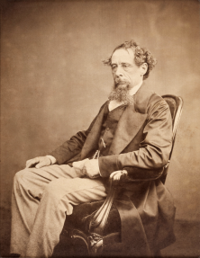
Джон Рональд Руэл Толкин
John Ronald Reuel Tolkien
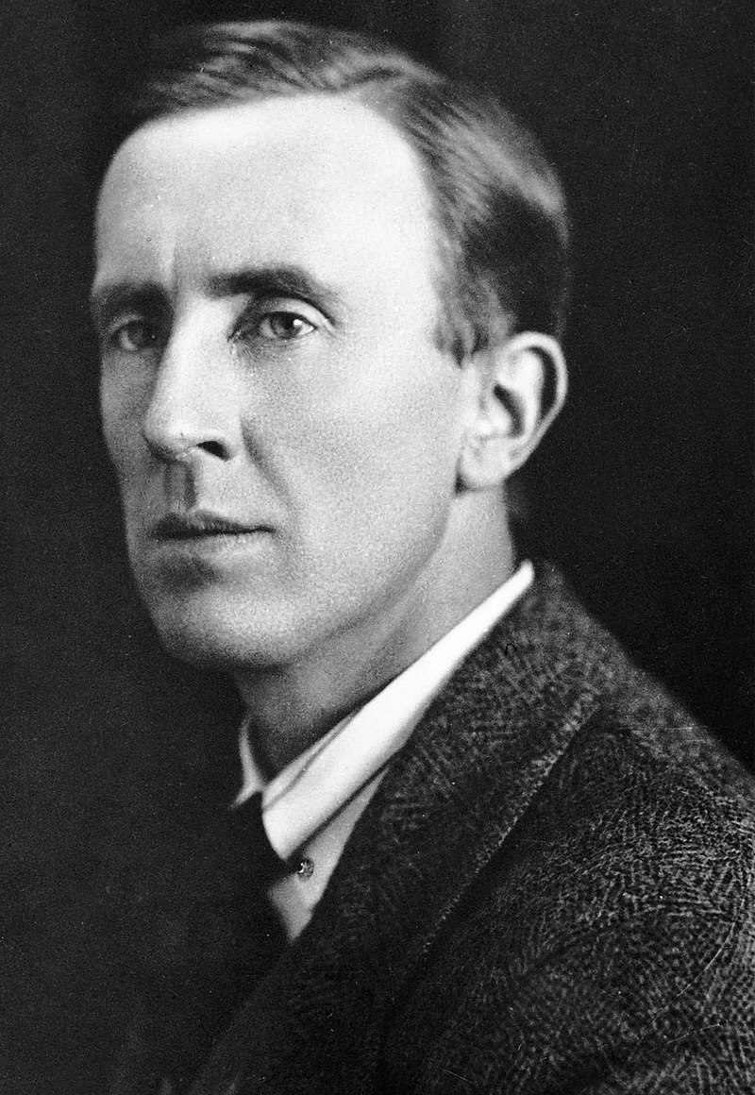
Джонатан Свифт
Jonathan Swift
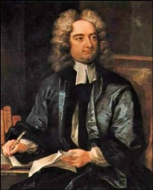
Алан Милн
Alan Milne
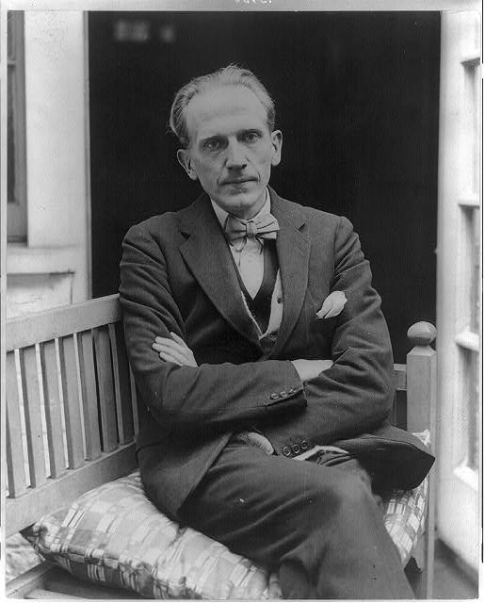
О. Генри
O. Henry
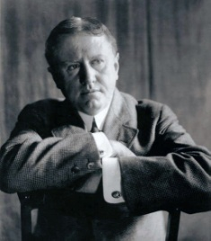
Льюис Кэрролл
Lewis Carroll
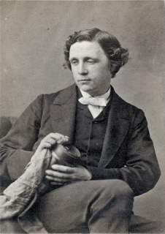
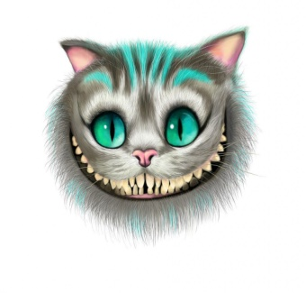
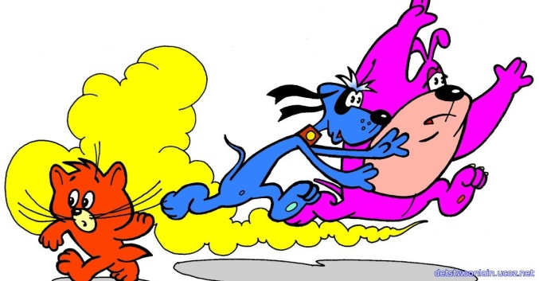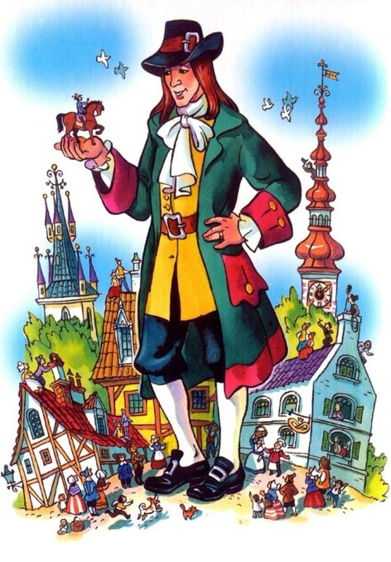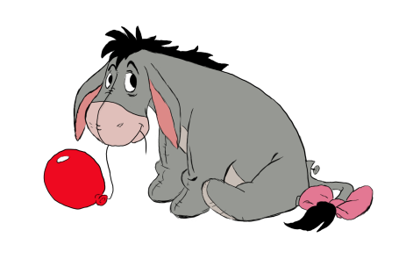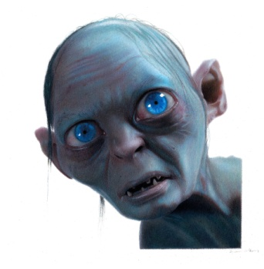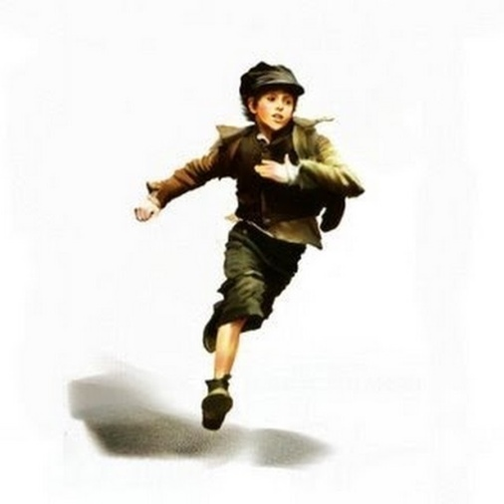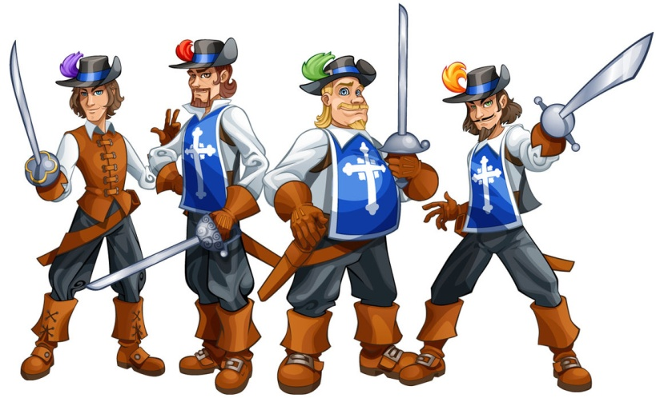
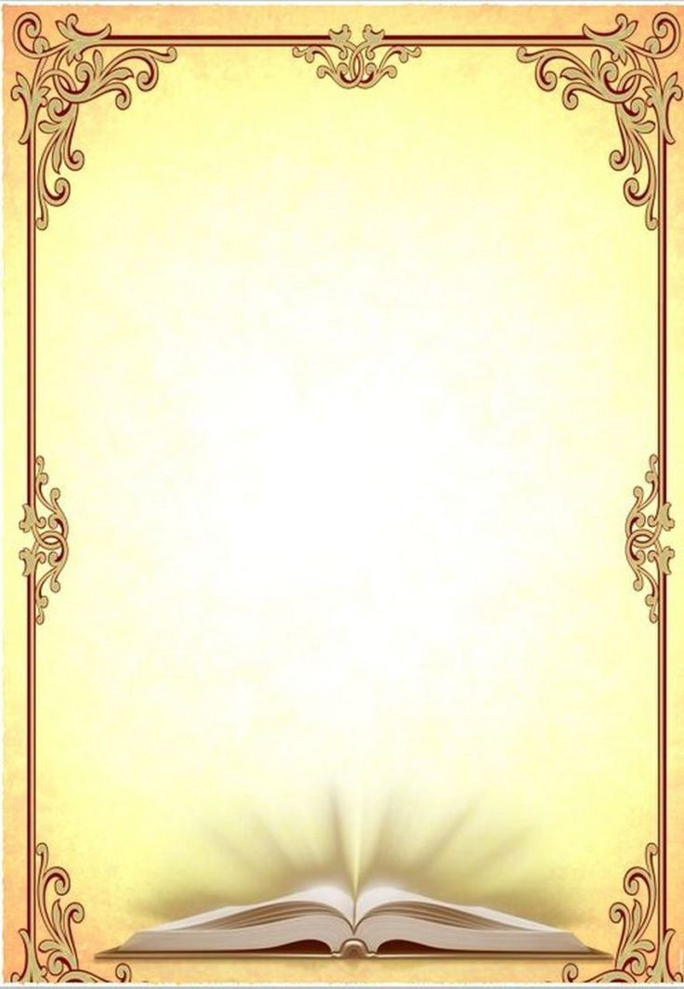
LITERATURE TEST
- Произведение Джонатана Свифта, в котором главный герой попал в страну с очень маленькими людьми:
- “A Tale of a Tab”
- “The Battle of the Books”
- “Travels into Several Remote Nations of the World”, in four Parts. By Lemuel Gulliver”
- Как звали мальчика из произведения А.Милн, который дружил с плюшевым мишкой?
- Christopher
- Winnie
- Oliver
- Кто из этих писателей не был англичанином?
- William Blake
- Charles Dickens
- Jules Verne
- Какое из этих произведений Дж.Р.Р.Толкиена было написано первым?
- “The Hobbit or There and Back Again”
- “The Lord of the Rings”
- “The Road Goes Ever On”

