Внеклассное мероприятие для старшеклассников
“Polymath”
Ключевые слова: different subject areas, game board, teammates, spokesperson, to be mindful.
Сведения об авторе: Шестакова Светлана Юрьевна, учитель английского языка высшей категории Международной школы завтрашнего дня ЮАО г. Москвы.
Домашний адрес: 143990 Московская область, г. Железнодорожный, ул. Адмирала Кузнецова, д.2 кв.32.
Мобильный телефон: 89163545485
Служебный адрес: 117208 г. Москва Сумской проезд 5А, Международная школа завтрашнего дня
Служебный телефон: 84953124408
E-mail: shestakovasvetlana@yandex.ru
Вступление
Основной задачей НОУ «Международная школа завтрашнего дня» является подготовка учащихся к взаимодействию с полилингвальным и поликультурным миром. В билингвальной модели школы осуществляется социокультурный подход к языковому образованию. Именно этот подход позволяет осуществить коммуникативно-ориентированное обучение иностранному языку как средству международного общения в тесной взаимосвязи с интенсивным использованием его как элемента познания мировой культуры. Игра для старшеклассников Polymath может найти свое применение, как среди учителей-предметников, так и педагогов дополнительного образования

Polymath
Today we are going to play a game which is called “POLYMATH”. A polymath is a person who is fluent in many fields of study. You will be asked questions from 7 different subject areas: Math, Language, English Grammar, Literature, Geography, History, and Russian Culture. You will be playing in 4 teams.
Look at the game board. It has color code: Red is the English Grammar area, Orange is Literature, Yellow – Math, Green – Geography, Indigo – Russian Culture, blue is Language, and purple is History.
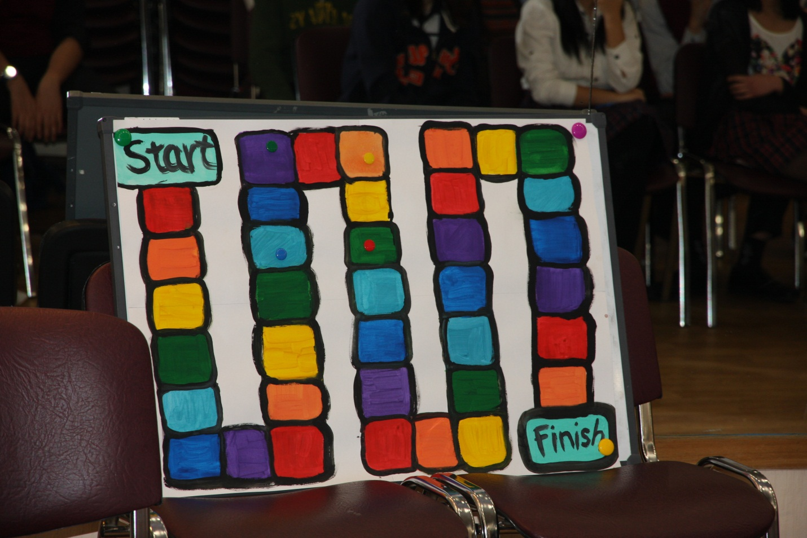
Your teams are represented by colorful magnets: team Green, team Red, team Blue, and team Yellow. Every team has a person responsible for each subject area.
For the first round you will roll a die and move your team’s magnet the appropriate number of spaces. The subject is then announced and the person responsible for this subject will step up and will be asked a question. That person will have 10 second to answer the question, no conferencing is allowed. If the members of the jury hear your teammates or the audience helping you out, the question will be disqualified and you will lose your turn, so be mindful of one another. If your answer the question correctly in the allotted 10 seconds, your team receives 5 points and moves 5 spaces forward. If you are unable to come up with the correct answer, after 10 seconds are up, your teammates may choose a spokesperson and say the answer. If it is correct, your team obtains 3 points. If your team doesn’t give the correct answer, I will allow the audience to answer it. But in this case your team does not get any points.
The team that gets to the finish line first wins.
Before we start our game let me introduce the members of our jury who will count your points.
Now we are ready to start, and I want to invite the captains of each to team to choose your turn. Take the paper out of bag and read your number.
Language Trivia
- Which food item takes its name from the French for “twice cooked”?
Answer: biscuit
- “Indices” is the plural of which word?
Answer: index
- What is the British English word for the eggplant?
Answer: aubergine
- Which Russian gave his name to the famous AK47 assault rifle?
Answer: Kalashnikov
- On a standard computer keyboard, which letter lies between the Q and the E?
Answer: “W”
- After whom is the month of July named?
Answer: Julius Caesar
- Which branch of mathematics takes its name from Greek for “earth measurement”?
Answer: geometry
- Azure and cobalt are shades of what color?
Answer: blue
- If an Australian friend offers you some “brekkie”, what are they offering?
Answer: breakfast
- Complete the saying: “An Englishman’s home is his______?
Answer: castle
Literature Trivia
- In the famous Russian novel, a married woman falls in love with a man named Vronsky. Name the novel and the author.
Answer: Anna Karenina by Leo Tolstoy
- Name the author and the title of the book that begins with the following line: “All children except one grow up”.
Answer: Peter Pan by J.M. Barrie
- Who wrote “A Hero of Our Time”?
Answer: Mikhail Lermontov
- Name the famous English writer from Stratford-upon-Avon and his three literary works.
Answer: William Shakespeare, may be Romeo and Juliet, King Lear, Othello
- Aleksander Pushkin, considered the founder of modern Russian literature, was born in what year?
Answer: 1799
- Who wrote the novel Les Miserables?
Answer: Victor Hugo
- This Russia writer was famous playwright, whose works include The Seagull and Uncle Vanya?
Answer: Anton Chekhov
- Which pioneering American poet and storyteller wrote “The Fall of the House of Usher” and “The Raven”?
Answer: Edgar Allen Poe
- This book was published more than two decades after the death of its author, and it is considered by some to be the founding text of magical realism.
Answer: Mikhail Bulgakov’s The Master and Margarita
- In his youth he wrote poetry in both Ukrainian and Russian, and he later wrote a story about Ukrainian Cossacks. Name the writer.
Answer: Nokolai Gogol
Geography Trivia
- Name the largest city in Latin America.
Answer: Mexico City
- In which city and country is the International Court of Justice?
Answer: the Hague, Netherland
- The former East African Colonies of Tanganyika and Zanzibar united to form what Independent country?
Answer: Tanzania
- The Great Victoria Desert is located in which country?
Answer: Australia
- Before the disintegration of the USSR at the end of 1991, it consisted of how many Soviet Union Republics?
Answer: 15
- What was the largest gold producing country in the world?
Answer: South Africa
- The island of Sri Lanka formerly was known as what?
Answer: Ceylon
- What is the highest mountain in Africa which is not part of any mountains chain?
Answer: Mt. Kilimanjaro
- Which ocean is the largest part of the hydrosphere?
Answer: the Pacific Ocean
- It is estimated that between 50 percent and 60 percent of all health costs in developing countries are caused by___
Answer: Unclean water

Russian Culture Trivia
- Some historians of Russian life argue that it originated from Japanese traditional dolls. However it’s known that Russian masters would make them in 1890’s. What is it?
Answer: Matryoshka Doll
- What is the world famous Russian soup that is made of beet.
Answer: borsch
- What animals ware the first to orbit around the Earth? Name them.
Answer: dogs: Belka , Strelka
- What is the traditional Russian winter footwear?
Answer: valenki
- This holiday has its origins in both pagan and Christian traditions. In Slavic mythology, it is a celebration of the imminent end of the winter. On the Christian side, it is the last week before the onset of Great Lent.
Answer: Maslenitsa
- This device traditionally used to heat and boil water for tea. For boiling water the pipe is filled with solid fuel such as pine cones, charcoals, and wood chips. What is the name of the device?
Answer: Samovar

- These typical Russian shoes were invented in Russia a long-long time ago. They are made of bast and laces and were extremely popular among Russian peasants. What are they?
Answer: lapti
- Why is the main square in Moscow called Red Square?
Answer: the name came about because the Russian word красная (krasnaya) can mean either "red" or "beautiful. This word, with the meaning "beautiful", was originally applied to Saint Basil's Cathedral and was subsequently transferred to the nearby square.
- What are the two Russian royal dynasties?
Answer: Rurik and Romanov
- Who was the founder of the Russian navy and St. Petersburg?
Answer: Peter the Great
English Grammar Trivia
- List the four main types of sentence.
Answer: declarative, interrogative, exclamatory, imperative

- An action verb has voice. In which voice does the subject of the sentence receive the action?
Answer: passive
- A regular plural noun ends in "s." To make it possessive, what do we add?
Answer: an apostrophe after the “s”
- What kind of verb never has a direct object?
Answer: intransitive or linking or state of being
- Name the three cases of personal pronouns.
Answer: Nominative, Objective, Possessive
- What kind of adjective follows a linking verb?
Answer: predicate adjective
- A verb form ending in ‘ing’ may be used as part of a verb phrase, as an adjective, and in one other way. What is the third way?
Answer: Gerund
- List the three main types of sentences.
Answer: simple, compound, complex
9. A paragraph covers only one idea or topic, usually stated in the first sentence, which is called the __________ sentence.
Answer: topic
10. Among other information, the dictionary gives the correct spelling of a word, its pronunciation, its __________divisions, and its part of__________.
Answer: syllable: speech
World History Trivia
1. Whose early life is described in the following sentences?
He was born the son of King Philip II of Macedonia in 356 B.C. He studied under the famous Greek philosopher, Aristotle, who taught him much of Greek learning. He was able to discuss science, philosophy, music, and literature with the learned men of his time. His interest and great ability, however, was in commanding men.
Answer: Alexander the Great.
2. What political system is described in the following sentences?
It was the dominant practice in Europe between A.D.500 and 1300. The various areas of Europe broke down into small political units. Great nobles arose in many areas, usurping the authority of the king or ruler, conquering lands and giving out fiefs.
Answer: feudalism.
3. What was started after the event is described in the following sentences?
It was in Sarajevo in Bosnia in June of 1914 when the heir of the Austria-Hungarian throne, Archduke Ferdinand, was assassinated by a Serbian revolutionary.
Answer: World War I.
4. Who was the Renaissance scientist who explained how planets moved around the sun?
Answer: Kepler
5. The Last Supper a famous Renaissance painting was a masterpiece of whom?
Answer: Leonardo da Vinci
6. In the year 1815, the Battle of Waterloo was fought between which countries?
Answer: Britain and France
7. In which country Aztec civilization was originated?
Answer: Mexico
8. Who is known as “Father of History”?
Answer: Herodotus
9. The first newspaper in the world was created in what country?
Answer: China
10. During World War I, what new military technique led to unprecedented number of combat deaths?
Answer: trench warfare
Math Trivia
- Improper fractions can be divided into two groups. One group is whole numbers. Name the other.
Answer: mixed numbers
- What is the name of the next larger place value following the hundred millions place value?
Answer: one billions
- To divide two fractions, you must invert the __________ before multiplying.
Answer: divisor
- What is the common endpoint of two rays called?
Answer: vertex
5. Two angles are placed together and form a 90° angle. Are they obtuse, supplementary, or complementary angles?
Answer: complementary
6. The sizes of two angles of a triangle are given as 45° and 90°. Figure the size of the third angle.
Answer: 45°
7. Within the groups of objects called sets, the individual objects are called ___.
Answer: elements
8. If every element of Set A is also an element of Set B, then Set A is a __ of Set B.
Answer: subset
9. What geometric figure is defined as a quadrilateral with both pairs of opposite sides parallel?
Answer: parallelogram
10. Change this percent into a decimal: 67%.”
Answer: .67
Sources:
http:/www.iteslj.org/questions
World Geography, Accelerated Christian Education, Inc., 2022 , ## 1097-1108
World History, Accelerated Christian Education, Inc., 2019, ##97-108
Algebra I, Accelerated Christian Education, Inc., 2000, ## 1097-1108
English I, Accelerated Christian Education, Inc., 2021, 33 1085-1096

