«Развитие креативного мышления на уроках английского языка в рамках реализации функциональной грамотности»
Креативное мышление — компонент функциональный грамотности, под которым понимают умение человека использовать свое воображение для выработки и совершенствования идей, формирования нового знания, решения задач, с которыми он не сталкивался раньше. По версии PISA, креативное мышление также способность критически осмысливать свои разработки, совершенствовать их.
Роль креативного мышление в жизни ребенка? Одаренный ребенок- креативный ребенок. Как творческий развитый человек может легко приспособиться к любой деятельности? Безусловно, будучи учеником школы с начальных классов необходимо в каждом ребенке заметить креативность, иными словами «Изюминку».
В примерной основной образовательной программе начального общего образования в содержание учебного предмета четко указаны требования: учащиеся должны уметь писать, оформлять поздравительные открытки с опорой на образец (с днём рождения, Новым годом, Рождеством) с выражением пожеланий.
В педагогической деятельности на любом уровне образования немаловажную роль играет профориентация. Безусловно, выпускники с развитым креативным мышлением с легкостью смогут усвоить любую профессию. У них будет возможность создавать необычные товары, которые будут востребованы.
Task 1. Jane has got a birthday party. She`s making an invitation cards for her future guests. At the shop she was suggested to buy a ready invitation –card, unfortunately, Jane didn`t like it at all. You`d help her and draw a better one. You`ll use the drawing tools.
Task 2. You`d give the original, unusual title to your card. Сhoose one of the best variant.
- It` ll be fun!
- I`m looking forward our meeting!
- One! Two! Three! Let`s begin!
- Please, don`t be late!
Task 3. You can use the text to answer the questions.
How can the guests get acquainted with each other? You`ll write several options. They must be differ from each other, at the same time, everybody would like it.
A lot of friends came to Jane`s birthday party. There are classmates, relatives among them. Many friends don`t know each other. They meet for the first time.
How can you help them to get acquainted?
Task 4. It`s time to congratulate Jane. Her mum suggested to hold a competition of compliments. You` d say the best complement.
Task 5. After party Jane takes apart her new toys, which were given in her birthday. She noticed that there are several identical dolls. Jane needs an advice. What should she do? Choose the best answer.
- take the dolls to a kindergarten or points for receiving unnecessary things
- announce a contest of good deeds on social networks, the winner of which will get a doll
- leave the dolls in the entrance or on the playground so that anyone can take them
- place an ad on the Internet that dolls are given as a gift.
Task 6. At the end of the party Jane`s guests decided to draw a greeting poster for her.
What kind of greeting poster would you suggest? Draw your original poster that would be differ from the poster that your friends drew.

Task 7. Reflecting on the inscription for the poster, the guys offered several ideas. Choose the most unusual and original inscription for a greeting poster. (There are several options )
*Happy birthday! May the lucky star always accompany you!
* Happy birthday congratulations! We wish you happiness and joy!
* Happy birthday! May all wishes come true!
* Happy birthday! Run towards the wind of joy and the bright dream of the heart!
Task 8. In memory of the holiday, Jane decided to give each guest a magnet. Help her to draw a sketch for a magnet that not everyone will think about. The sketch of the magnet should convey the atmosphere of celebration and fun.

Раздел «Food» Для учащихся 6 класса
Task 1. Mother decided to Mom decided to clean up the kitchen and put on the table a number of products that were out of place. These products are shown in the table:
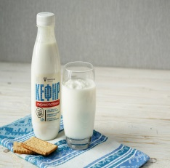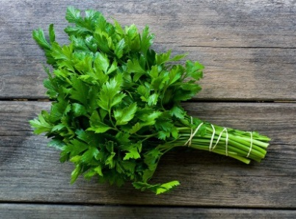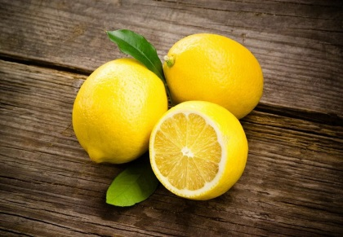
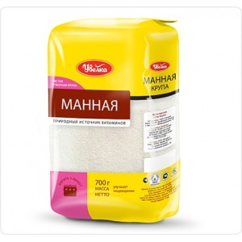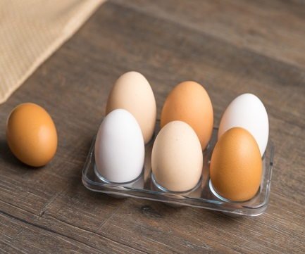
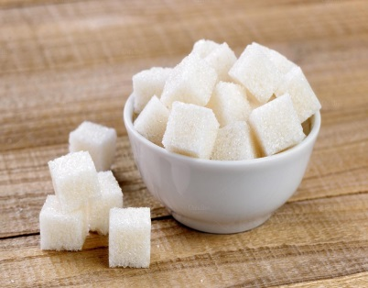
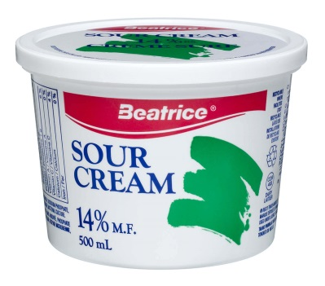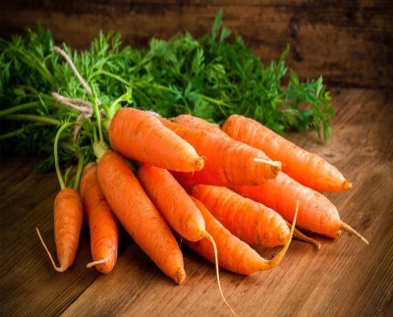
Mom asked the children to divide all the products into groups. Help the guys fulfill their mother's request.
Write down at least three ways to divide these products into groups. Each method you propose should allow division into two or more groups. All products of the same group should have some common property.
Task 2. Your friends suggested the following ways to divide products into groups. Mark with the sign «+» the way of grouping products that, in your opinion, mom will like the most.
- according to the state of the substance: liquid and solid
- according to colour
- by storage method
- by frequency of use.

