План-конспект урока по теме «Our pets»

Цель урока: развитие коммуникативных умений и навыков в процессе общения на иностранном языке

Задачи:
- научить учащихся узнавать и произносить звук [æ] в словах, словосочетаниях и предложениях;
- отработать лексические единицы по теме «Питомцы»;
- научить использовать модальный глагол can в отрицательных предложениях;
- содействовать развитию умений аудирования;
- cохранение и поддержка интереса к иноязычной речевой деятельности.

Прогнозируемый результат: предполагается, что к концу урока учащиеся смогут рассказать об умениях своих питомцев, используя изученные на уроке ЛЕ и грамматический материал.

- Warm-up

- Good morning, children! I’m glad to see you. Sit down, please. How are you?
- …
- I’m fine, thank you. Look at the blackboard, please. There are some pictures. What can you see in these pictures?*

(Cat, budgie, snake, swim, jump, etc.)

- Right! There are different pets and actions. So today’s topic is “Our pets and their actions” and we are going to learn how to say what animals can and can’t do.

Let’s sing our song about pets and the sounds they make.

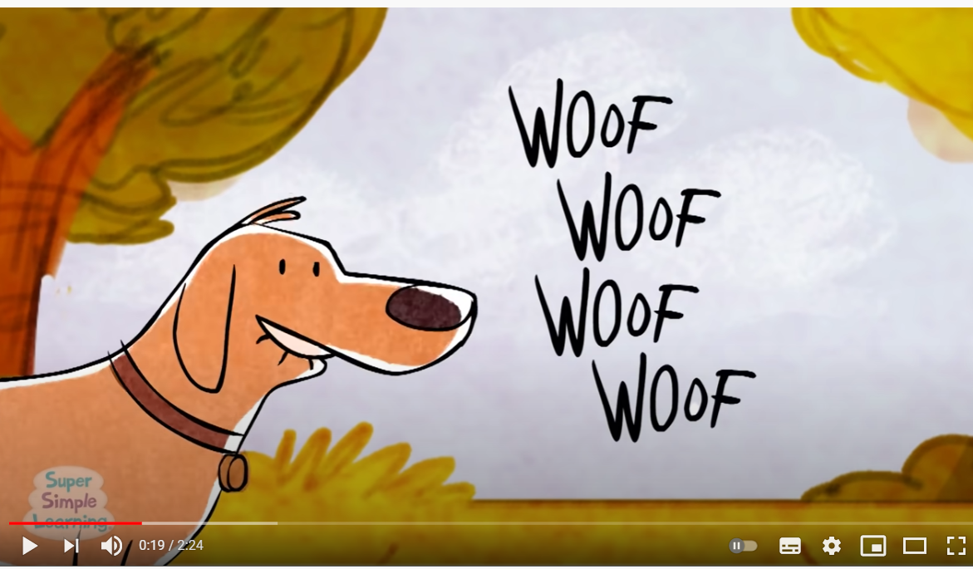
(Источник: https://www.youtube.com/watch?v=pWepfJ-8XU0)

- Well-done!

- Checking homework

Let’s check your homework and we’ll start with the revision of your vocabulary.
I have this little ball. I’ll throw it to you and say the word in Russian; your task is to catch the ball and say the word in English. Here we go!

It’s time to check your little projects about your pets. So who wants to be the first?

- Pronunciation drill.

Children, repeat after me the sound [æ]. What letter does give us this sound?

Look at the blackboard and repeat, please.

A little cat, a little cat,
A little cat is not very fat.
It is not fat, because it is sad.
It is very, very sad

- Now I will read different words. When you hear the word with sound [æ], you need to clap your hands.

a table, a map, a book, a dog, a box, a cat, a lamp, a flag, a kitten, a parrot, can, a mouse , a kangaroo.

- Listening and reading

Open your books at page 112-113. At first look at the pictures. What pets can you see here? Do you know their names? What do you know about them? (*)

Let’s listen to the audio about Susie, Lucky and Peter. Answer what the cat and the dog сan do.

Let’s divide the roles and act out this story. (*) I’ll give you some time to prepare.

V. Speaking

Look at the text again. What happened to the dog in this story? Find this sentence.
Lucky: I can’t climb the trees.

- Great! Can you translate this sentence?

Let’s study the chart with the rule.

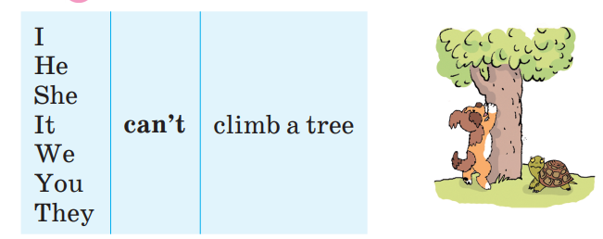
Let’s train a little bit. Look at the pictures. What can you tell me about these pets? What can they do? What can’t they do?

VI. Moving activity

You’ve worked hard and I think you are a bit tired. So let’s have some rest. I will say the actions and you need to mime them. Here we go!

VII. Speaking and writing

I’ll give you a set of cards with the pets. I’ll read the riddles and your task is to guess them and show me the right picture.

Look at the blackboard. Here we have many pictures with the pets and the actions. You need to match them and make up the right sentences about these pets using our modal verb ‘can’.

VIII. Reading

Open your books at page 115. Find exercise 3a. Let’s read the descriptions of the pets, find the mistakes and correct them.

IX. Homework

And now open your record books and write down your home task for the next lesson.

X. Round-up

‘Snowball game’. What can a budgie do? T: What can’t the budgie do? etc.
P_{1:} It can walk (sing, dance, hide).
P_{2:} It can’t swim. It can’t dance.

And it is time to get marks for the lesson. Your marks are...
That’s all for today. Thank you for your work. Goodbye!

